Design and Finite Element Analysis of Hybrid Glass–Carbon Composite Leaf Spring for Heavy Vehicle Applications
ABSTRACT
Leaf springs play a vital role in heavy vehicle suspension systems by supporting loads, absorbing shocks, and ensuring ride stability. Conventional steel leaf springs, though widely used, exhibit major drawbacks such as high weight, susceptibility to fatigue failure, and reduced efficiency under repeated cyclic loading conditions. These limitations necessitate the development of lightweight and high-performance alternatives to improve overall vehicle efficiency. Traditional systems rely heavily on steel due to its strength and availability; however, the increased weight leads to poor fuel efficiency and higher maintenance costs. To overcome these issues, this study proposed the design and analysis of a composite leaf spring using a hybrid Glass Fiber Reinforced Polymer (GFRP) and Carbon Fiber Reinforced Polymer (CFRP) material. The geometric modeling was carried out using Computer Aided Three-Dimensional Interactive Application (CATIA), and structural analysis was performed using Analysis System (ANSYS) software to evaluate stress, deformation, and fatigue behavior under different loading conditions. The hybrid composite structure effectively combined the high strength of carbon fibers with the flexibility and cost efficiency of glass fibers, resulting in a lightweight yet strong design. The results indicated reduced stress and deflection while maintaining sufficient stiffness for heavy vehicle applications. Additionally, proper layering minimized stress concentrations and improved fatigue life. The significant weight reduction contributed to enhanced fuel efficiency and overall vehicle performance. Thus, the proposed composite leaf spring design proved to be a reliable, efficient, and economically viable alternative for modern heavy vehicle suspension systems.
Key words: Leaf Spring, Composite Leaf Spring, Analysis System (ANSYS), Stress Analysis, Weight Reduction, Fatigue Analysis.
1. INTRODUCTION
A spring is a fundamental elastic component designed to absorb, store, and release mechanical energy by deforming under load and regaining its original configuration once the load is removed. Among various suspension elements, semi-elliptical leaf springs are extensively adopted in light and heavy commercial vehicles due to their simplicity, load-bearing capability, and reliability; they are also commonly implemented in the rear suspension of passenger cars. A typical leaf spring assembly comprises multiple flat steel strips, known as leaves or blades, arranged in descending order of length. These leaves are initially formed with a predefined curvature, referred to as camber, which allows them to progressively straighten when subjected to external loads. The longest leaf, termed the master leaf, is equipped with eye-shaped ends for mounting purposes, while the remaining shorter leaves are called graduated leaves. The entire assembly is clamped together using steel bands or clips, enabling the structure to function based on the principle of a beam of uniform strength, ensuring efficient stress distribution along its length.
In operation, the leaf spring is mounted directly on the vehicle axle and supports the entire weight of the vehicle body. The front eye of the spring is rigidly attached to the chassis frame through a pin joint, whereas the rear eye is connected via a shackle mechanism, which serves as a flexible linkage. This arrangement is crucial because, during vehicle motion over uneven road surfaces, the upward displacement of the wheels causes the spring to deflect, leading to a change in the effective length between its ends. The presence of the shackle accommodates this variation by allowing controlled movement at the rear end, thereby preventing excessive stress buildup. While the front end remains fully constrained in all directions, the rear end is permitted limited longitudinal motion. The mechanical behavior of the spring is influenced by its geometric parameters; a higher camber increases stiffness and results in a firmer suspension, whereas increased length enhances flexibility and provides a smoother ride. For this reason, rear springs are typically designed longer than front springs to improve comfort and load distribution.
To ensure long service life and reliable performance, several design and maintenance considerations are incorporated into leaf spring systems. Surface treatment processes such as shot peening are applied to introduce compressive residual stresses, thereby improving fatigue resistance and delaying crack initiation. Additionally, rounding the edges of the leaves helps minimize stress concentration points. During operation, relative sliding between adjacent leaves generates inter-leaf friction, which contributes to a certain level of damping but may also produce noise, wear, and fretting corrosion, particularly in the presence of moisture. To mitigate these issues, protective coatings like phosphate layers, as well as thin liners made of soft metals such as zinc, are used to maintain consistent frictional characteristics. In some designs, inserts made from rubber, wax-treated fabric, or oil-impregnated materials are placed between leaves to enhance performance and reduce wear. Protective covers, either metallic or fabric-based, are sometimes employed to prevent the ingress of dirt and to retain lubrication, with metallic covers often designed in a telescopic form to accommodate changes in spring length. Regular maintenance, including cleaning and lubrication using graphite-based oils, is essential for optimal performance; however, in systems utilizing rubber bushings, lubrication is unnecessary due to their self-damping, low-noise, and wear-resistant properties, along with their ability to tolerate slight misalignments.
2. LITERATURE SURVEY
Z. Zahavi, et al. [1] investigated the mechanical response of leaf spring systems and identified their behavior as highly nonlinear due to the combined effects of large deflections, high load intensities, and complex three-dimensional contact interactions between adjacent leaves. The study emphasized that multiple contact surfaces existed between individual plates, making analytical and numerical modeling particularly challenging. It was observed that, apart from acting as energy storage elements, leaf springs also contributed structurally by guiding motion along a predefined trajectory during deformation. The authors further highlighted that, under real operating conditions, leaf springs were subjected to repeated loading cycles reaching into millions, which significantly increased the likelihood of fatigue-induced failures. To better understand their dynamic performance, the study examined free vibration characteristics, including natural frequencies and mode shapes, which were considered essential for predicting resonance behavior and ensuring structural reliability. A. Strzat, et al. [2] performed an in-depth three-dimensional contact analysis of automotive leaf springs by formulating several mathematical and numerical models to simulate the interaction between individual leaves. Their approach focused on solving static contact problems, where load transfer and stress distribution across multiple contact interfaces were carefully analyzed. Different modeling techniques were implemented to evaluate variations in stiffness and deformation behavior. The computed results were systematically compared with experimental data to assess the accuracy and reliability of the developed models. Through this comparative analysis, the authors demonstrated that advanced numerical methods were capable of closely approximating real-world performance, thereby providing a strong foundation for improving leaf spring design and analysis.
F. C. Wang, et al. [3] explored the role of leaf springs within vehicle suspension systems by concentrating on active suspension control mechanisms. The study employed mechanical network theory to represent suspension dynamics and derived a generalized parameterization for stabilizing controllers applicable to a given system. Both active and passive suspension configurations were analyzed to understand their respective performance characteristics. The authors incorporated practical system parameters into their models, enabling realistic evaluation of suspension behavior under varying conditions. Their findings indicated that the integration of control strategies significantly enhanced ride comfort and vehicle stability, while also providing flexibility in adapting leaf spring performance to different operational requirements. I. Rajendran, et al. [4] conducted a finite element-based investigation on a typical passenger vehicle leaf spring to analyze its dynamic characteristics. The study utilized numerical simulation techniques to determine key parameters such as natural frequencies and corresponding mode shapes under simplified loading and boundary conditions. A basic road surface excitation model was considered to replicate real-world operating scenarios. The results provided valuable insights into vibration behavior, highlighting regions of maximum stress concentration and potential failure points. The authors concluded that finite element analysis served as an effective tool for evaluating structural performance and optimizing leaf spring design for improved durability and dynamic stability. N. P. Doshi, et al. [5] proposed a structural optimization approach for conventional multi-leaf spring systems with the objective of reducing weight and manufacturing cost without compromising performance. The authors employed finite element-based simulation using ANSYS to evaluate stress distribution and deflection characteristics under dynamic loading conditions. Their methodology involved reducing the number of leaves from 17 to 13 and analyzing the resulting structural behavior. It was observed that the modified configuration maintained acceptable stress limits and deformation characteristics while achieving a weight reduction of approximately 6 kg. Additionally, the simplified design contributed to nearly 20% cost savings, indicating that optimization of leaf count and geometry could significantly enhance efficiency while preserving functional integrity.
G. Gouda, et al. [6] developed advanced finite element models to investigate the behavior of composite leaf springs, with particular emphasis on parameters such as spring stiffness, shear stress, and fatigue life. The study considered composite circular leaf spring configurations and analyzed the influence of geometric ratios, specifically the ratio of inner to outer diameters, on overall performance. Both theoretical calculations and numerical simulations were carried out to evaluate stress distribution and deformation characteristics under varying loading conditions. The results demonstrated that composite materials offered substantial weight reduction compared to conventional steel springs while maintaining adequate strength and durability. The authors concluded that optimized composite designs, particularly those with specific geometric ratios, exhibited superior performance and could be effectively utilized in both light and heavy commercial vehicle applications. M. M. Petunia, et al. [7] conducted a comprehensive comparative investigation between traditional steel mono leaf springs and mono composite leaf springs fabricated using E-glass/epoxy material. Their study combined experimental testing and numerical simulation to evaluate performance under static loading conditions. Experimental analysis was performed using a hydraulic static load testing setup, where deflection and strain measurements were recorded using dial indicators and strain gauges, respectively. Parallelly, three-dimensional modeling was carried out using Pro-E software, and finite element analysis was conducted using ANSYS to validate the experimental findings. The results indicated that composite leaf springs exhibited lower deflection but experienced higher stress levels compared to steel springs. Despite this, the composite design achieved significant weight reduction while maintaining structural integrity. The authors also observed minimal variation between experimental and simulation results, confirming the reliability of computational methods in predicting performance. Y. N. V. Santosh Kumar, et al. [8] focused on the design, modeling, and analysis of mono composite leaf springs using E-glass/epoxy material as a replacement for conventional steel springs. The study emphasized the superior mechanical properties of composite materials, particularly their high strength-to-weight ratio and improved stiffness characteristics. The authors developed the geometric model using Pro-E software and performed structural analysis using ANSYS to evaluate stress and deflection behavior under loading conditions. Their findings revealed that the composite leaf spring weighed only about 39.4% of the conventional steel spring, resulting in an overall weight reduction of approximately 60%. Furthermore, the stress values were found to be within permissible limits, indicating that the composite design was structurally safe and efficient. The study concluded that composite mono leaf springs provided a highly effective alternative to traditional steel springs, especially in applications where weight reduction and performance optimization were critical.
3. PROPOSED SYSTEM
Conventional design methods of leaf springs are largely based on the application of empirical and semi-empirical rules along with the use of available information in the literature. The functions of springs are absorbing energy and release this energy according to the desired functions to be performed. So leaf springs design depends on load carrying capacity and deflection. Hence the Force Motors Trax Cruiser is consider for design of leaf spring.
Step (1): Material of Leaf Spring
- Material selected steel: 50 Cr 1 V 23
- Composition of material:
  - 0.45% C
  - 0.1–0.3% Si
  - 0.6–0.9 % Mn
  - 0.9–1.2 % Cr
Step (2): Basic Data of Force Motors Trax Cruiser Leaf Spring
- Total length of the spring (Eye to Eye) = 1800 mm
- No. of full length leaves (n ) = 02
- No. of graduated leaves (ng) = 06
- Thickness of leaf (t) = 25 mm
- Width of the leaf spring (w ) = 180 mm
- Young’s modulus ( E ) = 2 × 10⁵ N/mm²
- Central band 110 mm wide (Ineffective length)
- Tensile strength (σ) = 1900–2400 N/mm²
- Yield strength (σy) = 1800 N/mm²
- Total load = 10000 Kg
- BHN = 500 – 580 HB with hardened and tempered
Step (3): Basic Requirement of Load
- Maximum capacity = 10000 Kg
= 10000 × 10
= 100000 N
Force Motors Trax Cruiser is equipped with 4 nos. of semi elliptical leaf spring
So load acting on the leaf spring assembly =
= 100000 / 6
= 16,666.6 N
Step (4): Calculation of the Loaded Leaf Spring
- Consider the leaf spring is cantilever beam. So the load acting on the each assembly of the leaf spring is acted on the two ends of the leaf spring. Load acted on the leaf spring is divided by the two because of consideration of the cantilever beam
2 × W = 16,666.6 N
W = 8,333.33 N
- For support and clamping of the leaf spring the “U” bolt is use and the distance between the “U” bolt is 110 mm. This is considered as an unbent portion of the leaf spring. Ineffective length of the leaf spring is as under:
i = 110.00 mm
Effective Length of the spring:
2 × L = 1800 – 2(110)
2 × L = 1716.67
L = 852.33 mm
Step (5): Calculations of the Stress Generated in the Leaf Spring
- Material of the leaf spring is 50 Cr 1 V 23
- Property of the material are as under:
Tensile strength (σt) = 190 – 240 Kgf/mm²
= 1900 – 2400 N/mm²
Yield strength (σy) = 180 Kgf/mm²
= 1800 N/mm²
Modulus of elasticity (E) = 200000 N/mm²
BHN = 500 – 580 HB with hardened and tempered
Allowable Stress
By considering the factor of safety for the safety purpose of the leaf spring is 1.5 for automobile leaf spring
Tensile strength (σ) = 1900 / 1.5
= 1266.66 N/mm²
Yield strength (σy) = 1800 / 1.5
= 1200 N/mm²
Bending Stress
σb = (6 × W × L) / (n × b × t²)
σb = (6 × 8333.33 × 852.33) / (6 × 60 × 25 × 25)
σb = 189.453 N/mm²
- So, the stress generated in the leaf spring is lower than the allowable design stress. So design is safe.
Deflection
y = (6 × W × L³) / (n × E × b × t³)
y = (6 × 3562.5 × 852³) / (6 × 200000 × 60 × 25³)
y = 322.052 mm
Step (6): Calculation of the Pin of the Leaf Spring
Allowable bearing pressure of the eye (p) = 8 N/mm²
Take length of the eye (i) = 60 mm
Load acting on the eye are as under:
W = d × i × p
d = W / (i × p)
d = 8333.33 / (60 × 8)
d = 17.42 mm
D = 18 mm
- Considering factor of safety is 2
Length of the Pin
Length of the pin = Length of the eye + (2 × Clearance)
Take clearance = 2.50 mm per side
lp = 60 + (2 × 2.50)
lp = 65 mm
Bending Moment
M = (W × Lp) / 4
M = (8333.35 × 65) / 4
M = 1,35,411 N·mm
Section Modulus
Z = (π × d³) / 32
Z = 0.0982 × d³ mm³
Diameter Calculation
σb = M / Z
43 = 1,35,411 / (0.0982 × d³)
d = 16.98 mm
d = 17 mm
- So, internal diameter of eye is d = 17 mm
Shear Stress
(Considering bending stress 43.00 N/mm²)
In assembly of the leaf spring pin acting under the double shear action due to assembly structure of the leaf spring
W = (2 × π × d² × τ) / 4
τ = (W × 4) / (2 × π × d²)
τ = (8333.33 × 4) / (2 × π × 17²)
τ = 306.63 N/mm²
- Both the stresses; Tensile stress and shear stress are lower than the allowable stress. So design is safe.
Step (7): Calculations of the Length of Leaves
- Ineffective length of the leaf spring (l) = 110 mm
Leaf Lengths
Length of the smallest leaf:
= [(2 × L) / (n − 1) × 1] + 2(Ineffective length) / 3
= [(2 × 852.33) / 7 × 1] + 73.33
= 316.85 mm
Length of the 2nd leaf:
= [(2 × L) / (n − 1) × 2] + 73.33
= 560.34 mm
Length of the 3rd leaf:
= [(2 × L) / (n − 1) × 3] + 73.33
= 803.383 mm
Length of the 4th leaf:
= [(2 × L) / (n − 1) × 4] + 73.33
= 1047.32 mm
Length of the 5th leaf:
= [(2 × L) / (n − 1) × 5] + 73.33
= 1290.83 mm
Length of the 6th leaf:
= [(2 × L) / (n − 1) × 6] + 73.33
= 1534.33 mm
Length of the 7th leaf:
= [(2 × L) / (n − 1) × 7] + 73.33
= 1777.83 mm
- But 7th and 8th leaves are full length leaves and 8th leaf is known as a master leaf
Master Leaf Length
Length of master leaf = 2 × L₁ + (π / 2)(d + t) × 2
= 1800 + π(17 + 7) × 2
= 1950.7 mm
Step (8): Calculation of Radius
R = Radius to which the leaves should be initially bent
y = Camber of the spring
y(2R − y) = (L₁)²
176.26 (2R − 176.26) = (900)²
4. RESULTS AND DISCUSSION
Fig. 1 illustrates the three-dimensional model of the leaf spring assembly used for structural analysis, highlighting the geometric configuration, curvature profile, and layered leaf arrangement. The model represents the semi-elliptical leaf spring structure with multiple graduated leaves and master leaf, capturing the realistic boundary conditions and support regions. It depicts the eye ends and central clamping area, which play a crucial role in load distribution and stress transfer. The figure emphasizes the structural symmetry and load-bearing design characteristics essential for heavy vehicle suspension systems. This 3D representation serves as the foundation for further finite element analysis and performance evaluation.
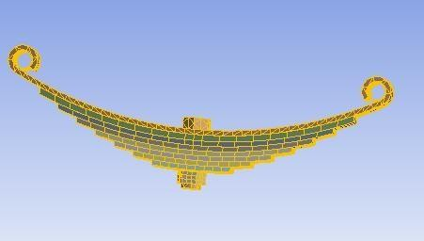
Fig. 1: 3d view of leaf spring
Fig. 2 depicts the total deformation distribution of the leaf spring under applied loading conditions, providing insight into displacement behavior across the structure. It highlights how deformation varies along the length of the spring, with maximum deflection occurring near the central region due to bending effects. The figure reflects the elastic response of the material and demonstrates the flexibility characteristics required for effective shock absorption. It also indicates the influence of boundary constraints and load application points on deformation patterns.
Fig. 3 illustrates the equivalent stress distribution within the leaf spring, representing the intensity of stress developed due to external loading. It captures the critical stress regions, particularly near the eye ends and central contact zones, where stress concentration is significant. The figure provides insight into the structural integrity and helps in verifying whether the induced stress remains within allowable limits. It also reflects the effectiveness of material selection and geometric design in resisting failure. This stress analysis is crucial for ensuring durability and safety under operating conditions.
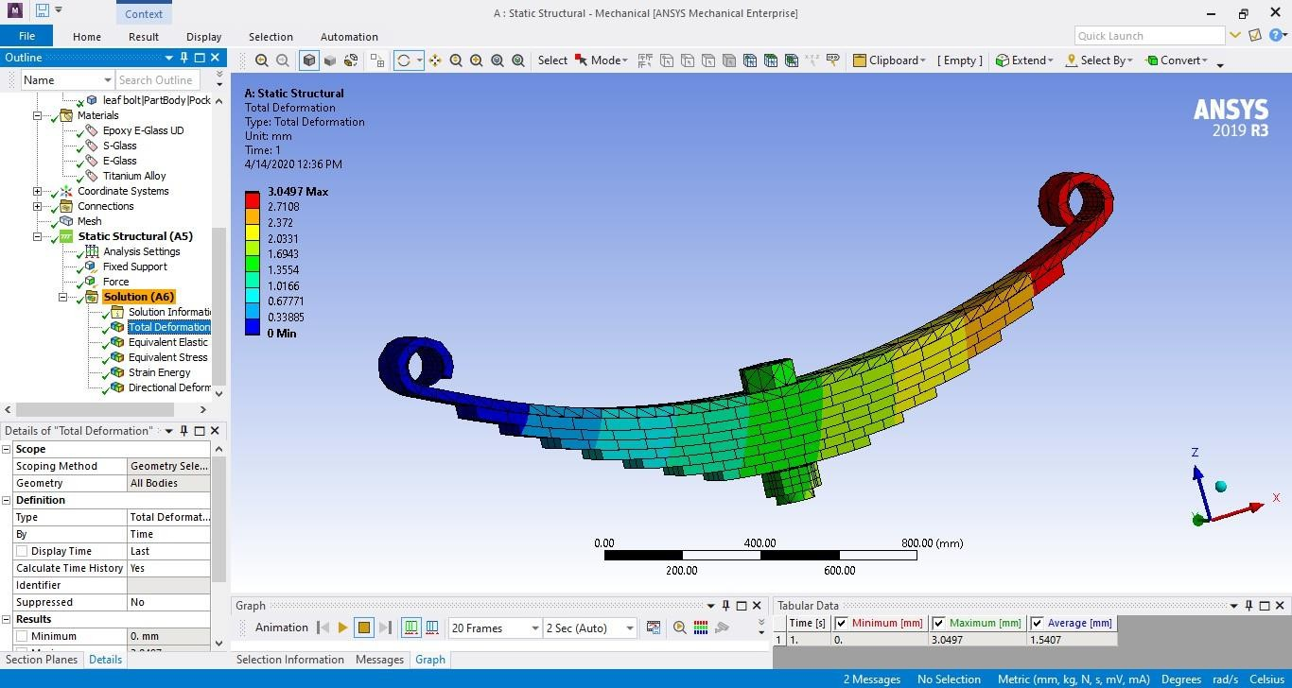
Fig. 2: Total Deformation
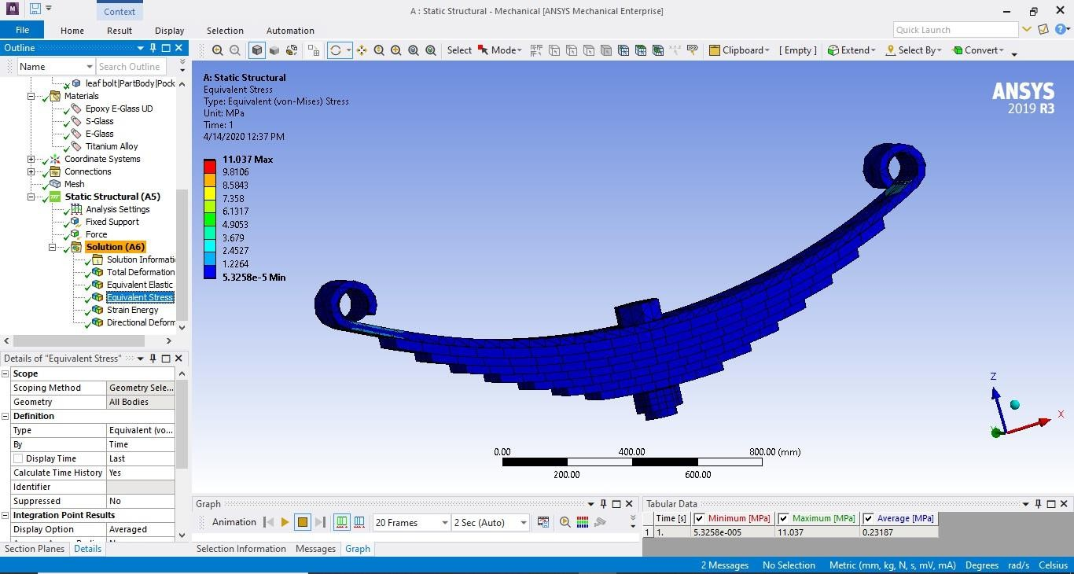
Fig. 3: Equivalent Stress
Fig. 4 depicts the directional deformation behavior of the leaf spring along a specified axis, showing how displacement varies in a particular direction under load. It highlights the bending characteristics and directional flexibility of the spring structure. The figure demonstrates the variation in deformation magnitude across different regions, indicating the influence of geometry and support constraints. It provides a deeper understanding of anisotropic deformation patterns and structural response. This analysis is important for assessing performance under real-world loading scenarios and validating design efficiency.
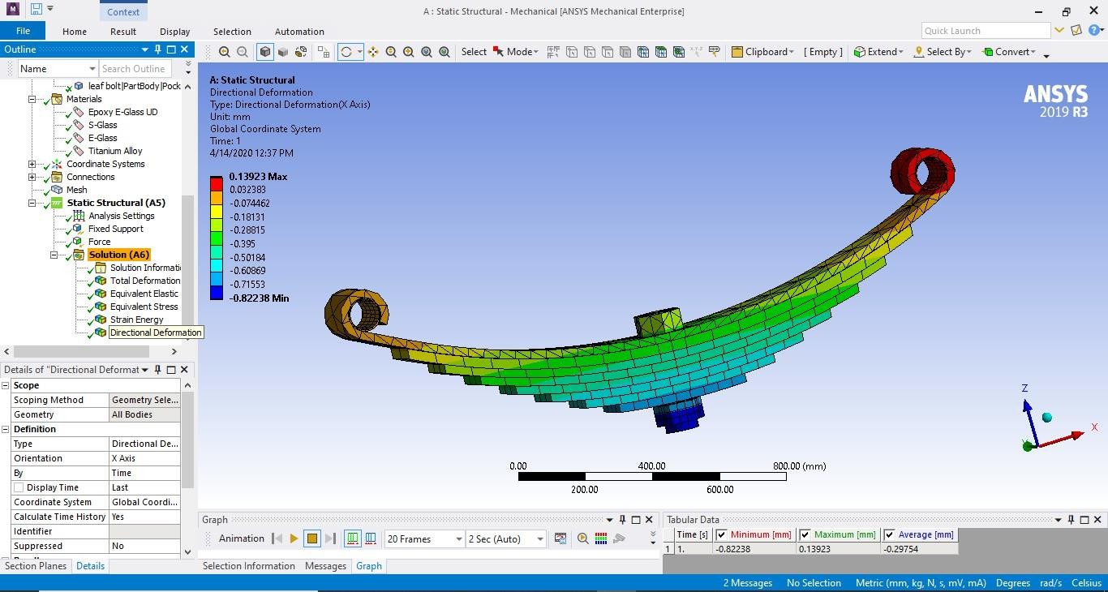
Fig. 4: Directional deformation
The results table presents the numerical outcomes of the finite element analysis of the leaf spring, highlighting key performance parameters under applied loading conditions. The total deformation ranges from 0 to 0.66235 mm, indicating that the structure undergoes limited displacement and maintains structural stability within acceptable limits. The equivalent elastic strain varies from 8.6931×10⁻¹⁰ to 9.4879×10⁻⁵ mm/mm, showing that the material experiences very low strain, which confirms that it operates well within the elastic region. The equivalent stress values range between 5.8876×10⁻⁵ MPa and 7.4877 MPa, which are significantly lower than the allowable stress limits, ensuring safe operation without risk of failure. The strain energy ranges from 1.6458×10⁻⁹ to 0.75471 mJ, representing the energy absorbed by the spring during deformation and indicating efficient energy storage capability. The directional deformation varies from -0.17817 mm to 0.031298 mm, reflecting the displacement behavior along a specific axis and demonstrating controlled bending characteristics.
Table 1: Results Table
RESULTS | MINIMUM | MAXIMUM | UNITS | TIME(S)
Total deformation | 0 | 0.66235 | mm | 1
Equivalent Elastic Strain | 8.6931e-10 | 9.4879e-5 | Mm/mm | 1
Equivalent Stress | 5.8876e-5 | 7.4877 | Mpa | 1
Strain Energy | 1.6458e-9 | 0.75471 | Mj | 1
Directional Deformation | -0.17817 | 0.031298 | mm | 1

5. CONCLUSION
The development and analysis of a heavy vehicle leaf spring using a glass–carbon composite material showed notable improvements compared to traditional steel springs, based on simulations performed in CATIA and ANSYS. Precise geometric modeling ensured accurate structural representation, while numerical analysis provided detailed evaluation of stress, deformation, and fatigue characteristics. The hybrid combination of carbon and glass fibers enhanced strength while maintaining flexibility and cost efficiency, leading to a lighter yet stronger structure. The results demonstrated reduced stress and deflection levels with sufficient stiffness for heavy-duty applications. Optimized layering of composite materials helped in minimizing stress concentrations and improving fatigue life. The reduction in overall weight contributed to better fuel efficiency and enhanced vehicle performance. The use of advanced design and analysis tools enabled reliable prediction of structural behavior. The composite leaf spring proved to be an efficient, lightweight, and economically viable alternative for modern heavy vehicle systems.
REFERENCES:
- R. N. Jazar, Vehicle Dynamics: Theory and Applications. New York, NY, USA: Springer, 2008, p. 455.
- A. Strzat and T. Paszek, “Three-dimensional contact analysis of a car leaf spring.”
- F.-C. Wang, “Control design and analysis of active and passive suspension systems using mechanical network theory.”
- I. Rajendran and S. Vijayarangan, “Finite element analysis of leaf spring for a passenger car.”
- N. P. Doshi, et al., “Analysis and optimization of leaf spring using ANSYS.”
- G. Gouda, et al., “Finite element modeling and analysis of composite leaf spring.”
- M. M. Petunia, et al., “Experimental and numerical investigation of mono composite leaf spring.”
- Y. N. V. Santosh Kumar and M. Vimal Teja, “Design and analysis of composite leaf spring using E-glass/epoxy material.”

